For the bonus project, I decided to do a geospatial project on two selected interstates. What I did actually is that I took two portions of I-77 and I-81 – shown in figure below – and visualize the segments with Unity. Then, I used the following color-coding to show the maximum temperature recorded in that location in the year 2016.

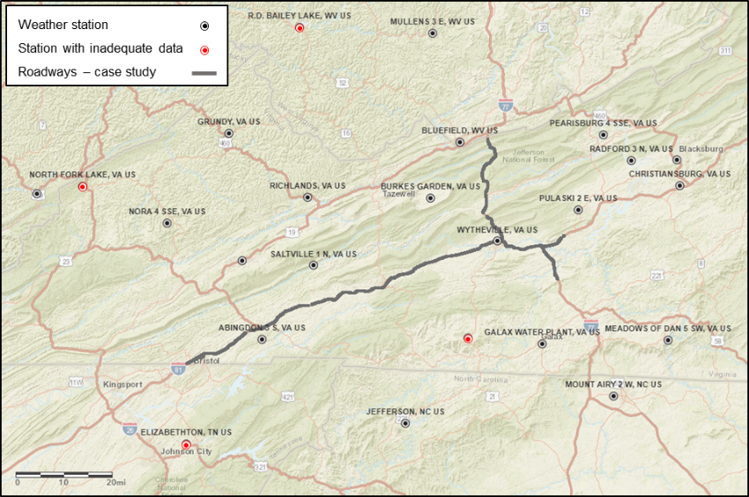

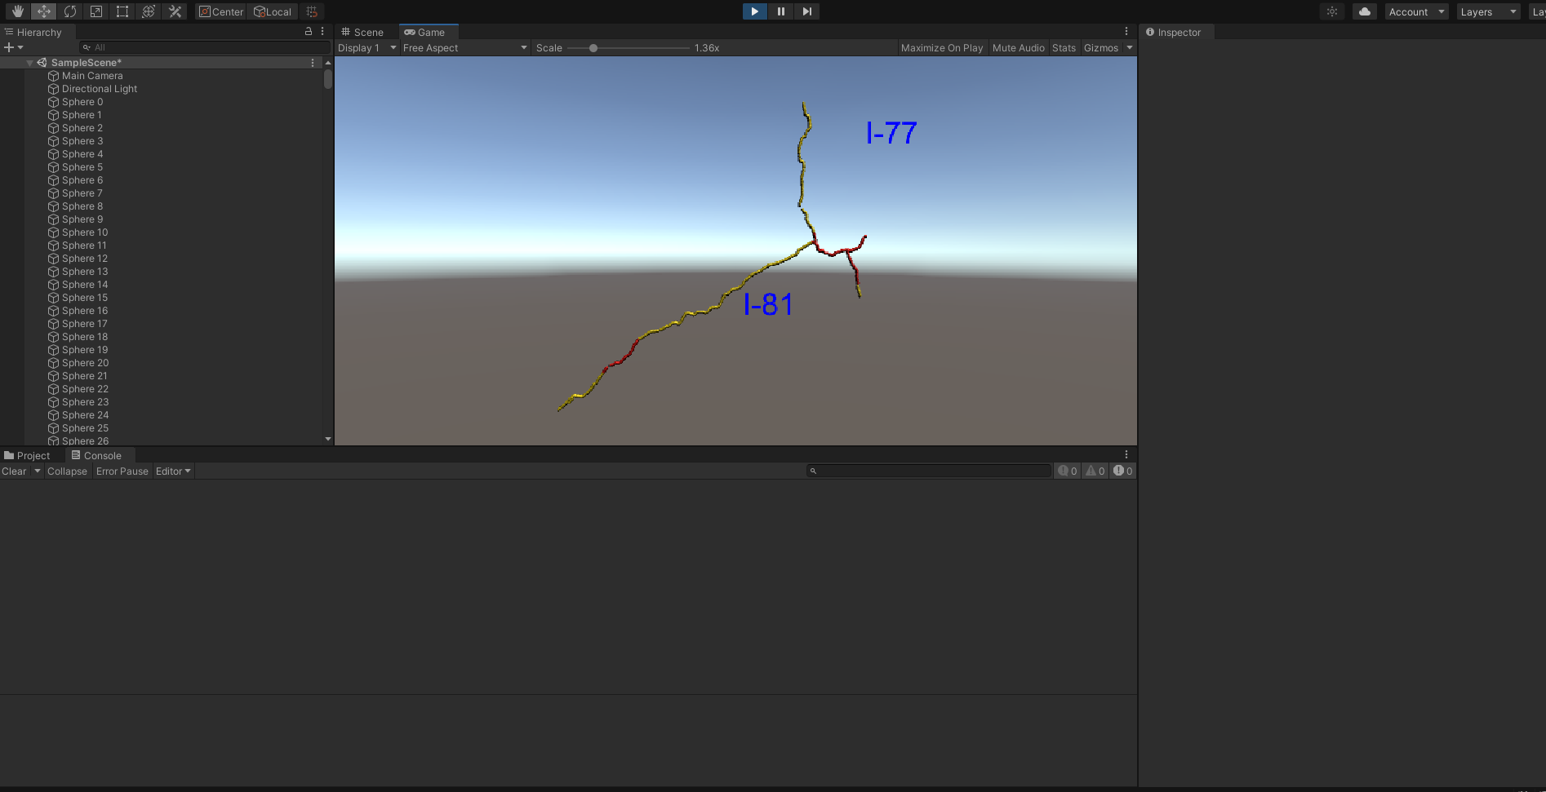

The data utilized in this project was part of a dataset that my colleagues and I prepared for another project that I was involved in. What we did is that we chose several weather stations that were located in the vicinity of the considered route and collected multiple features, including the maximum temperature used in this project for each weather station. The list of the utilized stations is provided in the below figure:

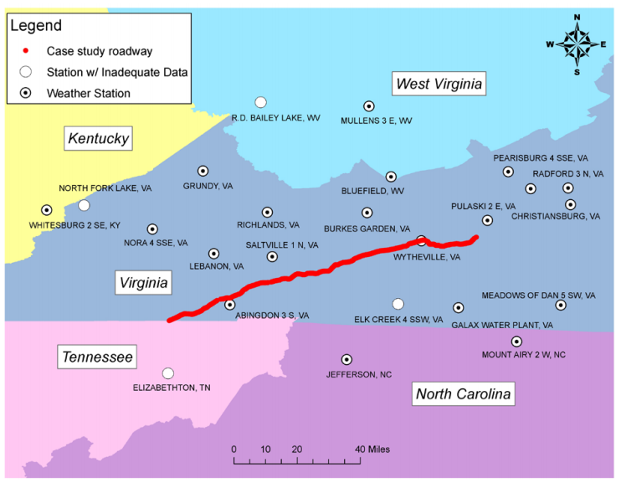

We extracted the weather data from the National Oceanic Atmospheric Administration (NOAA) database. We collected the data from 24 weather stations to cover our case study. We cleaned the dataset to minimize inaccuracies and missing information. We filtered the stations to the ones with more than 250 days of recorded data, which reduced the number of remaining stations to 20. We used the ordinary kriging to interpolate the extracted weather features onto each segment (adapted from [here](https://www.iaarc.org/publications/2020_proceedings_of_the_37th_isarc/condition_prediction_of_highway_assets_based_on_spatial_proximity_and_interrelations_of_asset_classes-a_case_study.html)).

The core idea of ordinary kriging method is that observed values at nearby locations are more related than those of farther points. To interpolate and predict values at unobserved points, spatial correlations and statistical relationships are considered. Semivariogram is used to represent and asses the spatial autocorrelation. Statistical functions are used to fit the semivariogram and model autocorrelations. With minimum variance, ordinary kriging is an unbiased prediction method, which considers spatial autocorrelation and statistical relationships between observed points. In ordinary kriging, it is assumed that the prediction at each location is a linear combination of observed values. This statement is shown in Equation 1:

|  |  |
| --- | --- |
|  | (1) |

Where is the prediction at location , ; i=1,…,n are linear coefficients, and i=1,…n are observations at locations . In ordinary kriging, the estimator is unbiased, which means that the predicted value at location is equal to the observed value at that location – as shown in Equation 2:

|  |  |
| --- | --- |
|  | (2) |

Additionally, values at unobserved points are predicted in way that the variance of the prediction error is minimized, based on Equation 3:

|  |  |
| --- | --- |
|  | (3) |

After preparing the dataset, as I mentioned, in this project, I only used TMAX feature from the collected dataset in the year 2016.

Below figure shows the color-coding used in this project.

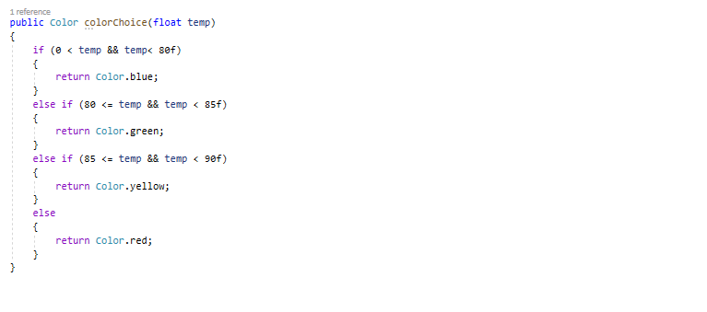

Because we cannot use the latitude and longitude directly in Unity, I somehow normalized them. But because the locations were too close, I multiplied them by 100 so that we get a bigger visualization. There are 1996 segments in the road.

